Marcos

Monday, April 26, 2021

2:44 PM

Marcos belongs to Microsoft Excel sheet programming flow

It is under Developer Tab , press Record Marcos.

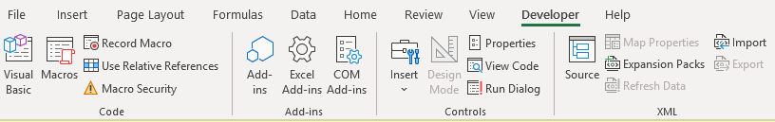

The Marcos will capture your movement and the function you used in the excel sheet.

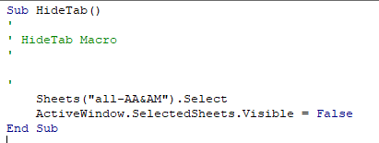

Dynamic programming can be applied to the structure.



Marcos

-to run marco, use alt+f8

-to open marco ,backend use alt+f11

You can capture as many functions as you want.

Best practice would be capture one function and name.

Dynamic Programming works- store formula and use It for next set of data without calculating them again.